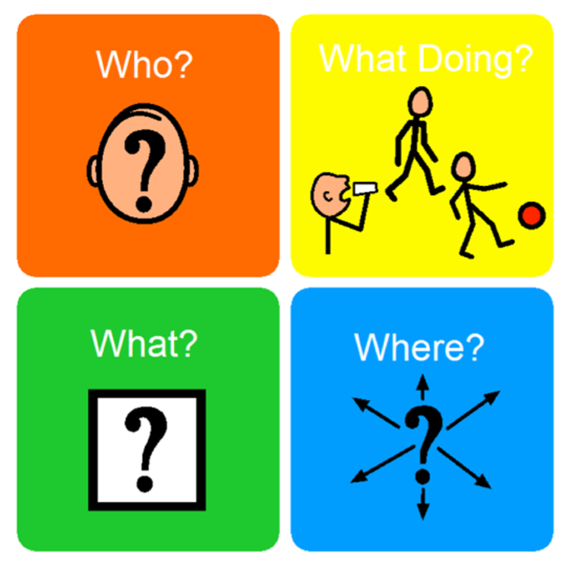

Show your child a sentence and encourage your child to build a sentence about the picture using correct word order Who doing what? Then you can gradually extend to Where? When? to add more detail and build more complex sentences.

Here are some examples of colour coded words that your child could use to build sentences


